Earthquake
All-natural earthquakes occur in the lithosphere.
- Seismic waves studies offer a full picture of the layered interior.
- An earthquake is, simply put, shaking of the earth’s crust.
- It is caused due to the energy release, which triggers waves that travel in all directions.
- The emanation of energy occurs along a fault.
- A fault is a sharp break in the crustal rocks.
Earthquake waves are of two types
P-waves are also known as the Primary waves. They are the first waves to arrive at the surface.
- S- Waves arrive after some time after the happening of earthquake and they are called secondary waves.
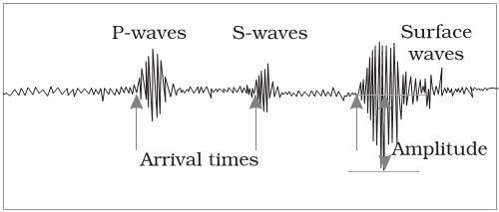
- All earthquakes are different in their intensity and magnitude. The instrument for the measurement of the vibrations is known as Seismograph
- Richter scale is used to measure the magnitude of the earthquake.

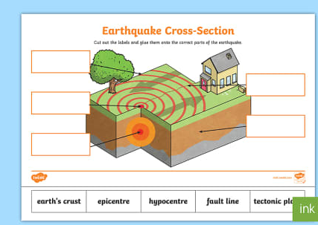
HOME WORK

