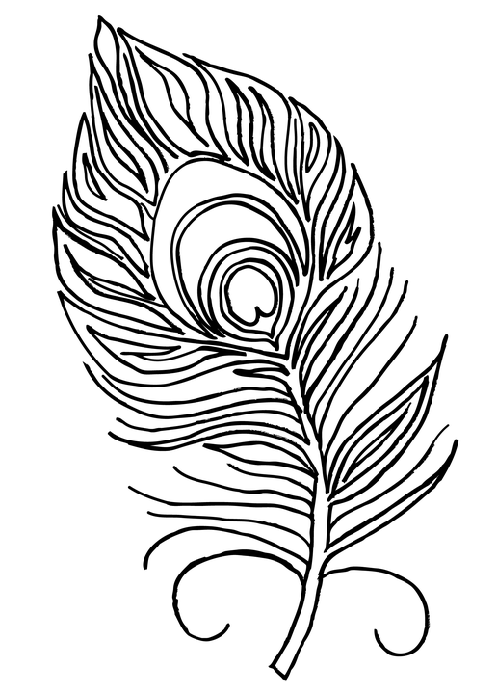
Colour this peacock feather using the colours described in the poem.

