WORKSHEET
CIRCLE THE LONGER AND CROSS THE SHORTER OBJECTS
DATE:30.06.21
Q1

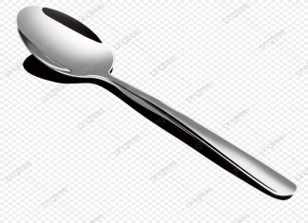

Q2


Q3



