Notebook Assignment
DT:06.07.21
1.Colour the One that is Full And Cross the One that is Empty
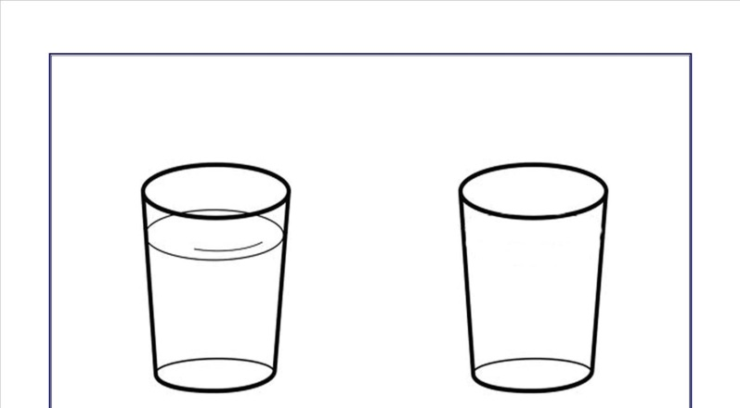

2. Which Pot is Full? Colour it. Cross The Empty One.
