Important Questions Geography Chapter-3 Drainage

3 marks Questions

Write a short note on Sunderban Delta.

Ans. The Sunderban Delta is the worlds’ largest and the fastest growing delta. Filled by various tributaries, the river Ganga reaches West Bengal.
The Sunderban Delta derived its name the Sundri tree which grows well in marshland. It is also the home of Royal Bengal tiger.

What is Drainage and drainage basin?

Ans. The term drainage means the river system of an area. It is a system of flowing water from the higher level to lower level.
Some small streams flowing from different directions come together to form the main river, which ultimately drains in to a large water body.
The area drained by a single river system is called a drainage basin.

Explain Water Divide with an example.

Ans. Water Divide is an elevated area or uplands which separate two drainage basins. Such uplands or elevated areas are known as Water Divide.
‘Ambala’ is located at the water divide between the Indus and Ganga River. It does not receive water from either of the two rivers.

From where does the Ganga originate and name the tributaries of Ganga River.

Ans. Water Divide is an elevated area or uplands which separate two drainage basins. Such uplands or elevated areas are known as Water Divide.
‘Ambala’ is located at the water divide between the Indus and Ganga River.

It does not receive water from either of the two rivers.

From where does the river Brahmaputra originate and name the tributaries of Brahmaputra River.
Ans. The Brahmaputra originates in Tibet east of Mansarowar Lake very close to the sources of the Indus and the Sutlej.
It is joined by many tributaries including the Dibangm the Lohit, the Kenula to form the Brahmaputra in Assam.

Two features A and B are marked in the given political map of India. Identify these features with the help of the following information and write their correct names on the lines marked on the map.
- A west flowing river

A river on which the world’s highest gravity dam is built On the same political map locate and label the following
- Chilka lake
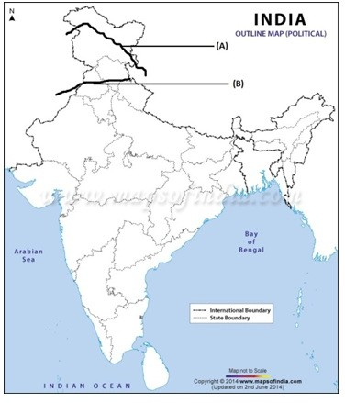

Ans.

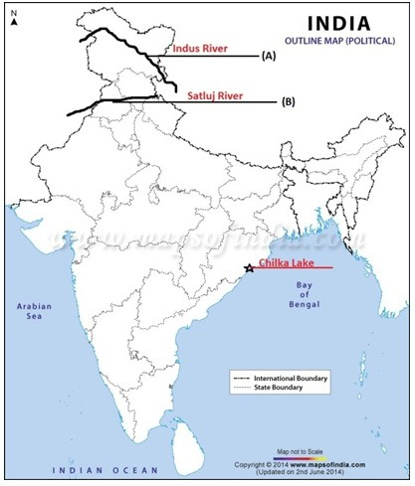

- From where does the Indus originate and name the tributaries of Indus River.

Ans. The Indus River originates in Tibet, near Lake Mansarowar flows towards west. Many tributaries the Zaskar, the Nubra, the Shyok and the Hunza, join it in the Kashmir region.
Near Mithankot in Pakistan, the Sutlej, the Beas, the Ravi, the Chenab and the Jhelum join together to enter the Indus.

Write a short note on river Tapi Basin.

Ans. The Tapi originates in the Satpura ranges in the Betul district of Madhya Pradesh. It is much shorter in the length flowing in a rift valley parallel to the narmada.
Its basin covers the parts of Gujarat, Madhya Pradesh and Maharashtra.
The coastal plains are very narrow lying between Western Ghats and the Arabian Sea.

Write a short note on Mahanadi basin.

Ans. The Mahanadi rises in the highlands of Chhattisgarh flowing through Orissa to reach to Bay of Bengal.
Its length is about 860 km.
The drainage basin includes Maharashtra, Chhattisgarh, Jharkhand and Orissa.

Write a short note on Krishna basin.

Ans. The Krishna rises from a spring near Mahabaleshwar extending over about 1400 km and reaches the Bay of Bengal.
The Tungabhadra, the Koyana, the Ghatprabha, the Musi and the Bhima are some of its tributaries.
Maharashtra, Karnataka and Andhra Pradesh are involved in its drainage system

Write a short note on Kaveri basin.

Ans. It also reaches the Bay of Bengal rising in the Brahmagri range of the Western Ghats. It particularly reaches in the south of Cuddalore in Tamil Nadu.
Its total length is about 760 km.
The Amravati, Bhavani, Hemavati and Kabini are its main tributaries.

Two features A and B are marked in the given political map of India. Identify these features with the help of the following information and write their correct names on the lines marked on the map.
- A Salt Water Lake

A river which form an estuary
On the same political map locate and label the following

Walur lake

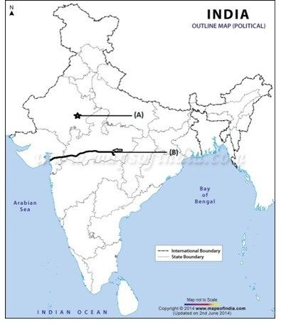
Ans.
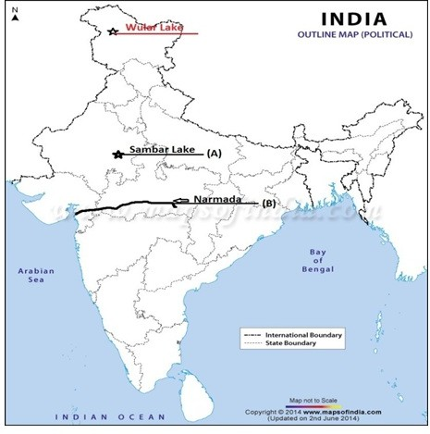

Write any three economic benefits of rivers.

Ans. Water from the rivers is basic natural resource, essential for various human activities. The banks of river have attracted settlers. These settlements have now become big cities.
The river water is used for irrigation, navigation, hydro power generation significantly. They are very useful particularly to a country like India.

Write down the features of the East Flowing Rivers.

Ans. These rivers originate from the Western Ghats and flow eastwards. They all form deltas at their mouths.
They drain into the Bay of Bengal. They have large volume of water. Example: Mahanadi, Godavari.

Write down the features of the West Flowing Rivers.

Ans. These rivers originate in Central India and flow eastwards. They form estuaries since they floe from rift valleys.
They drain into the Arabian Sea. They have lesser volume of water. Example: Narmada and Tapi

Explain the drainage patterns Rectangular and Radial.

Ans. A Rectangular Drainage pattern develops on a strongly joined Rocky terrain.
A Radial pattern develops when streams flow in different directions from a central peak or dome-like structure.
Examples of radial drainage patterns can be found on a small scale in the Aravalis and hilly terrains of central India.

Explain the drainage patterns Dendritic and Trellis.

Ans. The Dendritic pattern develops where the river channel follows the slop of the terrain. The stream with its tributaries resembles the branches of the tree, thus the name dendritic.

Example: The Ganga basin.
A river joined by its tributaries at approximately right angle develops a trellis patterns. A trellis drainage pattern develops where hard and soft rocks exist parallel to each other.
Example: The Narmada River System.

Two features A and B are marked in the given political map of India. Identify these features with the help of the following information and write their correct names on the lines marked on the map.
- A Dam

A Dam
On the same political map locate and label the following

Pulicat lake
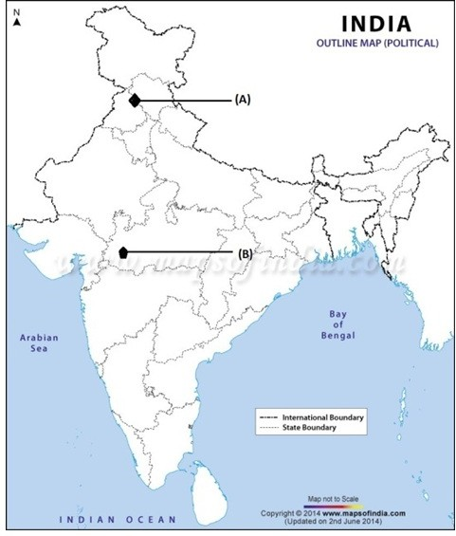
Ans.

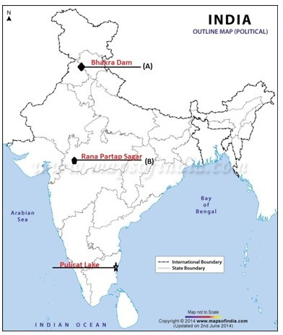

Which river is known as ‘Dakshin Ganga’? Give it three features.

Ans. Godavari River is known as the ‘Dakshin Ganga’
It is the largest Peninsular River, which rises from the slopes of the Western Ghats in the Nasik district of Maharashtra.
The length is about 1500 km draining into Bay of Bengal.
Many tributaries join the Godavari such as the Purna, the Wardha, and the Penganga.

Write a short note on Indus Water Treaty of 1960.

Ans. This treaty was done by India and Pakistan.
According to this regulation of the Indus water treaty of 1960, India can use only 20% of the total water carried by Indus river system.
This water is used for irrigation in Punjab, Haryana and the Southern and western parts of

Rajasthan.

What are Salt-water lakes?

Ans. Spits and bars from lagoons in coastal areas like the Chilka Lake, the Pulkit Lake and the Kolleru Lake.
Some lakes are seasonal in the region of inland drainage including the Sambhar Lake in Rajasthan which is salt water lake. Its water is used for producing salt.

What are Fresh-water lakes?

Ans. Fresh water lakes are mostly found in the Himalayas. They originate from glaciers.
In other words, they formed the glaciers dugging out a basin which was later filled with snow melt.
The bigger example of such lake is the Wular Lake in Jammu and Kashmir which is the result of tectonic activities. It is the largest fresh water lake in India.

What are Man-made lakes?

Ans. The damming of rivers is an example of manmade lakes. The reservoir behind the dam is an example of mane made lakes. These dams are constructed for the generation of hydel power.
Guru Gobind Sagar Lake behind the Bhakra Dam is an example of manmade lake. The dams are also known as the Multipurpose River Projects.

Two features A and B are marked in the given political map of India. Identify these features with the help of the following information and write their correct names on the lines marked on the map.
- A River

A River
On the same political map locate and label the following

Krishna River

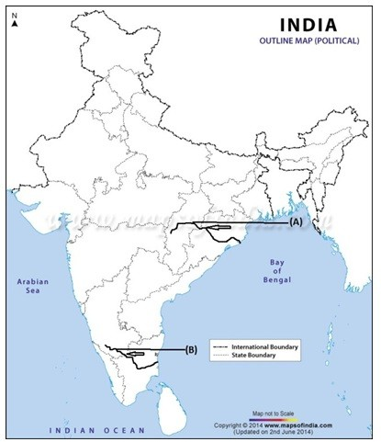
Ans.
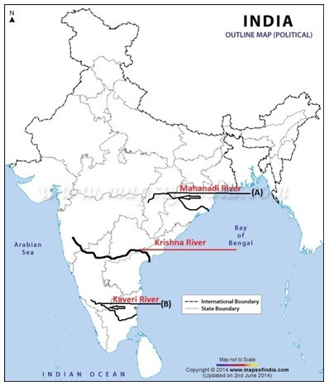

What are the benefits of lakes?

Ans. Lakes are very useful and important for human beings.A lake is useful in regulating the

flow of the river. It prevents flooding during heavy rainfall and it helps to maintain water level during the dry season. Lakes can also be used for developing hydel power.

What are the causes of river pollution?

Ans. The quality of water is affected by the growing domestic, municipal, industrial and agricultural demand for water. As result more and more water is being drained out of the rivers reducing their volume. Due to increasing urbanization and industrialization, the pollution level of many rivers has been rising day by day.
On the other hand industrial effluents and heavy load of untreated sewerage are only affected the quality of water but also the self cleansing capacity of the river.

Why are peninsular rivers seasonal in nature?

Ans. The flow of peninsular river is dependent on rainfall. The peninsular rivers have shorter and shallower courses as compared to their Himalayan Rivers.
The tributaries are very short and less in number and bring less amount of water.

Write a short note on Delta.

Ans. The triangular deposits made by the river at their mouth form delta. Deltas are formed in the regions of low tide and coastal plains. Deltas are fertile lands.
The river Ganga, the Krishna, the Godavari is some of the rivers which form delta.

Write a short note on Estuary.

Ans. The sharp edge at the mouth of the river devoid of any deposits id known as estuary. The regions of high tides and rift valleys witness estuaries.
Estuaries do not have fertile lands.Narmada and Tapi Rivers form estuaries.

Two features A and B are marked in the given political map of India. Identify these features with the help of the following information and write their correct names on the lines marked on the map.
i) A west flowing river ii) A river on which the world’s highest gravity dam is built

On the same political map locate and label the following
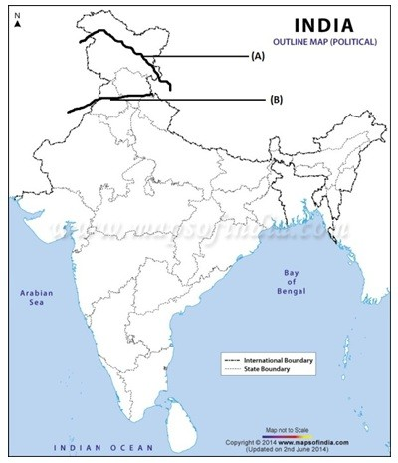
iii) Chilka lake

Ans.
