Types of Vegetation
In India, the following major types of vegetation are found:
- Tropical Evergreen Forests
- Tropical Deciduous Forests
- Tropical Thorn Forests and Scrubs
- Montane Forests
- Mangrove Forests
Let’s study them in detail.

Tropical Evergreen Forests
These forests are present in the Western Ghats and the island groups of Lakshadweep, Andaman and Nicobar, upper parts of Assam and Tamil Nadu coast.
- These forests grow best in areas having rainfall more than 200 cm with a short dry season.
- The trees reach great heights up to 60 metres or even above.
- It has the vegetation of all kinds i.e trees, shrubs and creepers giving it a multilayered structure.
- These forests appear green all the year-round.
- Important trees of this forest are ebony, mahogany, rosewood, rubber and cinchona.
- Common animals found in these forests are elephant, monkey, lemur and deer.

Tropical Deciduous Forests
These forests are also called the monsoon forests.
- They are spread over the region having rainfall between 200 cm and 70 cm.
- They shed their leaves about 6 to 8 weeks in the dry summer.
- In these forests, the common animals found are lion, tiger, pig, deer and elephant.
These forests are further divided into:
- Moist deciduous: These are found in areas having rainfall between 200 and 100 cm. Teak is the most dominant species of this forest. Bamboos, sal, shisham, sandalwood, khair, kusum, arjun and mulberry are other commercially important species.
- Dry deciduous: These are found in areas having rainfall between 100 cm and 70 cm. There are open stretches, in which teak, sal, peepal and neem grow.

The Thorn Forests and Scrubs
The natural vegetation consists of thorny trees and bushes. This type of vegetation is found in the north-western part of the country, including semi-arid areas of Gujarat, Rajasthan, Madhya Pradesh, Chhattisgarh, Uttar Pradesh and Haryana.
- Trees are scattered and have long roots penetrating deep into the soil to get moisture.
- The stems are moist to conserve water.
- Leaves are mostly thick and small to minimise evaporation.
- Acacias, palms, euphorbias and cacti are the main plant species.
- Common animals are rats, mice, rabbits, fox, wolf, tiger, lion, wild ass, horses and camels.

Montane Forests
Montane forests are the forests which are found in the mountains.
- The wet temperate type of forests are found between a height of 1000 and 2000 metres.
- At high altitudes, generally, more than 3,600 metres above the sea level, temperate forests and grasslands give way to the Alpine vegetation.
- Alpine grasslands are used for grazing.
- At higher altitudes, mosses and lichens form part of tundra vegetation.
- The common animals found are Kashmir stag, spotted deer, wild sheep, jack rabbit, Tibetan antelope, yak, snow leopard, squirrels, shaggy horn wild ibex, bear and rare red panda, sheep and goats.

Mangrove Forests
Mangroves are trees that live along tropical coastlines, rooted in salty sediments, often underwater.
- The mangrove tidal forests are found in the areas of coasts influenced by tides. Mud and silt get accumulated on such coasts.
- Dense mangroves are the common varieties with roots of the plants submerged underwater.
- Sundari trees are found in Ganga-Brahmaputra delta and provide hard timber.
- Royal Bengal Tiger is a famous animal in these forests.

Wildlife
India is rich in its fauna.
- Elephants are found in the hot wet forests of Assam, Karnataka and Kerala.
- One-horned rhinoceroses are found in Assam and West Bengal.
- Rann of Kachchh is the habitat for wild ass whereas the Thar Desert is the habitat for camels.
- The natural habitat of the Indian lion is the Gir forest in Gujarat.
- Tigers are found in the forests of Madhya Pradesh, the Sundarbans of West Bengal and the Himalayan region.
- Ladakh’s freezing high altitudes are home to yak, the shaggy horned wild ox, the Tibetan antelope, the bharal (blue sheep), wild sheep, and the kiang (Tibetan wild ass).
- In the rivers, lakes and coastal areas, turtles, crocodiles and gharials are found.
- Peacocks, pheasants, ducks, parakeets, cranes and pigeons are some of the birds inhabiting the forests and wetlands of the country.

Cause of Major Threat to flora and fauna
Every species has an important role in the ecosystem. Hence, conservation of flora and fauna is essential. About 1,300 plant species are endangered and 20 species are extinct. The main causes of this major threat to nature are:
- Hunting for commercial purposes
- Pollution due to chemical and industrial waste
- Rapidly cutting of the forests for cultivation and habitation

Government Initiative to Protect Flora and Fauna
The government has taken many steps to protect the flora and fauna of our country.
- 18 biosphere reserves have been set up in India to protect flora and fauna. 10 out of these have been included in the world network of biosphere reserves.
- Financial and technical assistance has been provided to many botanical gardens by the government since 1992.
- Project Tiger, Project Rhino, Project Great Indian Bustard and many other eco-developmental projects have been introduced by the government.
- 103 National Parks, 535 Wildlife Sanctuaries and Zoological gardens are set up to take care of natural heritage.
HOMEWORK FOR WEEK
Natural vegetation in India includes Tropical Evergreen Forests, Tropical Deciduous Forests, Montane Forests, Mangrove Forests and Tropical Thorn Forests. This map shows the natural vegetation of India.
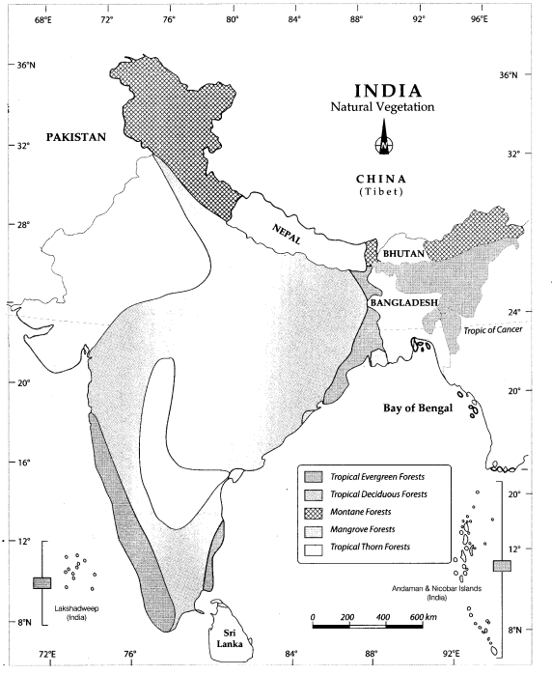
Question 1.
Locate and label the following items on the given map
1 Tropical Evergreen Forests
2 Montane Forests
3 Tropical Thorn Forests
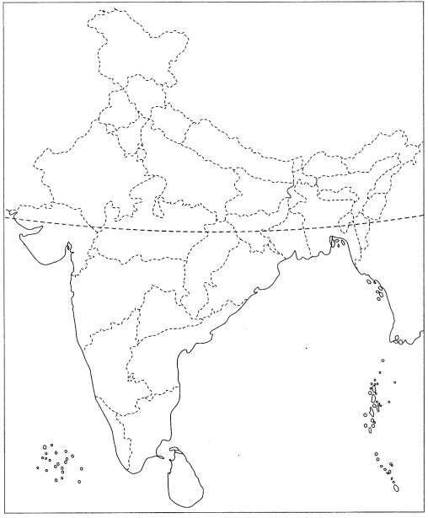
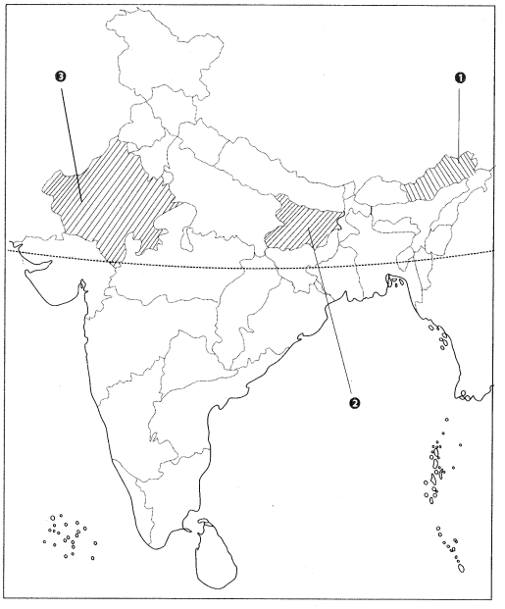
Question 2.
Features are marked by numbers in the given political map of India, Identify these features with the help of the following information and write their correct names on the lines marked in the map.
1 A type of vegetation
2 A type of vegetation
3 A type of vegetation

