WORKSHEET ASSESSMENT
DATE: 25.6.2021
Q 1. Colour the same objects and cross the different one

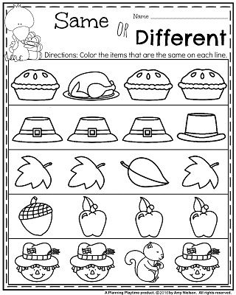

Q2.Colour the big object & cross the small object:-
