Revision- 1
Geography Chapter 1

The Earth in the Solar System

Question 1: Answer the following questions briefly.

How does a planet differ from a star?
Answer. Stars: Stars are very big and hot celestial bodies made up of gases. They have their own heat and light, which they emit in large amounts.
Planets: Planets are celestial bodies, usually smaller than stars.
They do not have their own heat and light. They are lit by the light of stars.

What is meant by the ‘Solar System’?
Answer. The term 'Solar System' refers to the family of the sun. The Sun, eight planets, satellites and some other celestial bodies known as asteroids, comets and meteoroids together form the Solar System.

Name all the planets according to their distance from the Sun.
Answer. In order of their distance from the sun, the planets are Mercury, Venus, Earth, Mars, Jupiter, Saturn, Uranus, and Neptune.

Why is the Earth called a unique planet?
Answer. The earth is called a unique planet because:
  - It is the only planet which has favorable conditions that support life. It is neither too hot nor too cold.
  - It has water and air, which are very essential for our survival.
  - The air has life-supporting gases like oxygen.

Why do we see only one side of the Moon always?
Answer. The Moon moves around the Earth in about 27 days. It exactly takes the same time to complete one spin on its own axis. As a result, only one side of the Moon is visible to us on the Earth.

What is the Universe?
Answer. A galaxy is a huge system of billions of stars, and clouds of dust and gases. Millions of such galaxies make up the universe.

Question 2: Tick the correct answers.

- The planet is known as the “Earth’s Twin” is
  - Jupiter
  - Saturn
  - Venus
- Which is the third nearest planet to the Sun?
  - Venus
  - Earth
  - Mercury
- All the planets move around the Sun in a
  - Circular path
  - Rectangular path
  - Elongated path
- The Pole Star indicates the direction to the
  - South
  - North
  - East
- Asteroids are found between the orbits of
  - Saturn and Jupiter
  - Mars and Jupiter
  - Earth and Mars

Answer:

- (iii) Venus
- (ii) Earth
- (iii) Elongated path
- (ii) North
- (ii) Mars and Jupiter

Question 3: Fill in the blanks.

- A group of forming various patterns is called a .
- A huge system of stars is called .

- is the closest celestial body to our Earth.
- is the third nearest planet to the Sun.
- Planets do not have their own and .

Answer:

- A group of stars forming various patterns is called a constellation.
- A huge system of stars is called a galaxy.
- The Moon is the closest celestial body to our Earth.
- Earth is the third nearest planet to the Sun.
- Planets do not have their own heat and light.

HOME WORK

I. Multiple Choice Questions
Choose the correct option to complete the statements given below:
(i) Full moon night occurs once every……….
(a) day
(b) 15 days
(c) 20 days
(d) month.
(ii) The Hindi word for the New Moon night is ……….
(a) Amavasya
(b) Krishna Paksha
(c) Poornima
(d) none of these.
(iii) The sun is …………
(a) a star
(b) a celestial body
(c) the head of the solar system
(d) all of these.
(iv) Ursa Major is a/an
(a) star
(b) constellation
(c) galaxy
(d) asteroid.
(v) Which of these was a planet till 2006 but is now a “dwarf planet”?
(a) Neptune
(b) The Sun
(c) Pluto
(d) Solaris.
(vi) The term “Blue Planet” indicates presence of
(a) land
(b) water
(c) oxygen
(d) all of these.
Answer:
(i)—(d),
(ii)—(a),
(iii)—(d),
(iv)—(b),
(v)—(c),
(vi)—(b).
II.Fill in the Blanks
Fill in the blanks with appropriate words to complete each sentence:
(i) The Amavasya night occurs about ……….. days after the Poornima night.
(ii) Stars are celestial bodies that are ……….. and ………….
(iii) The planets do not possess their own ……….. and …………
(iv) The Small Bear constellation is better known as the ………….
(v) The Greek word which is the origin of the word “planets” means ………….
(vi) Three planets having rings around them are ………… , ………. and …………
(vii) …….. are elongated fixed paths in which a celestial body always remains.
(viii) Venus is similar to the earth in its ………. and ………….
(ix) The shadows on the moon’s surface are due to ……….. , ……… and …………
(x) Meteoroids heat up and bum due to …………

Answer:(i) fifteen
(ii) big, hot
(iii) heat, light
(iv) Saptarishi
(v) wanderers,
(vi) Jupiter, Saturn, Uranus
(vii) Orbits
(viii) size, shape
(ix) mountains, plains, depressions
(x) friction.
III.True/False
State whether these sentences are true (T) or false (F).
(i) The Sun appears bigger and brighter than the other stars because it is indeed so.
(ii) Saptarishi and Ursa Major are two different constellations.
(iii) The Pole Star is known to have a fixed position in the sky.
(iv) The earth is the only planet that has a natural satellite.
(v) Pluto was declared a “dwarf planet” in August 2006.
(vi) The earth is the third-largest planet in the solar system.
(vii) The geoid shape is not perfectly spherical.
(viii) The moon takes about the same time in rotating about its axis once as it does to complete a revolution around the earth.
Answer: (i) False, (ii) False, (iii) True, (iv) False, (v) True, (vi) False, (vii) True, (viii) True.
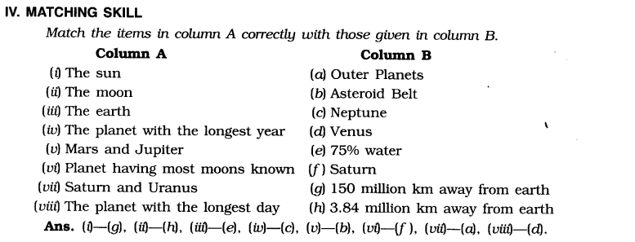
V. Very Short Answer Type Questions
1. Name two celestial bodies visible only in the night sky.
Answer: The moon and the stars are celestial bodies visible in the night sky.
2. Why do we not feel the heat and light of the stars, even though they are so big and hot?
Answer: We do not feel the heat and light of the stars since they are very far away.
3. From which Greek word is the word ‘planet’ derived?
Answer: The word ‘planet’ is derived from the Greek word ‘Planetai’.
4. What does the solar family consist of? [V. Imp.]
Answer: The solar family consists of the sun, planets, their satellites, and asteroids and meteoroids.
5. What is the shape of the orbits in which planets revolve around the sun?
Answer: The orbits of planets are elliptical (Le. elongated) in shape.
6. Which planet is called “Earth’s twin” and why?
Answer: Venus is called “Earth’s twin” because it is similar to Earth in its shape and size.
7. What is “Geoid”?
Answer: A sphere with its ends flattened at poles (just like earth) is called geoid.
8. Why is earth called “blue planet”? [V. Imp.]
Answer: Earth appears blue from when seen from the outer space, since it has over 2/3rd water. So it is called blue planet.
9. How much time does the moon take to revolve once around the earth?
Answer: The moon takes approximately 27 days to revolve once around the earth.
10. What is the difference between the moon and INSAT? [V. Imp.]
Answer: The moon is a natural satellite of the earth while INSAT is an artificial satellite.
11. What are asteroids?
Answer: Asteroids are the numerous tiny celestial bodies which revolve around the sun and are mainly found between the orbits of Mars and Jupiter.
12. What is a meteoroid?
Answer: Small pieces of rocks which move around the sun are called meteoroids.
VI. Short Answer Type Questions
1. Name the two extreme shapes of the moon. When and at what intervals do they occur?
Answer: The moon is seen in its two extreme shapes on the Full Moon night arid the New Moon night. The Full Moon. The Full Moon means the moon in its full circular shape. The New Moon. The New Moon means the moon that can not be seen. The New Moon occurs on the fifteenth day and the Full Moon occurs on the last day of the Hindi calendar month.
2. What is the Pole Star? How can the Saptarishi be used to locate it? [Imp.]
Answer: The Pole Star is the star that is known to retain its position in the sky always. We can locate the position of the Pole Star with the help of the constellation Saptarishi. If an imaginary line is drawn joining the “pointer stars” of the Saptarishi and extended further, it will point to the Pole Star.
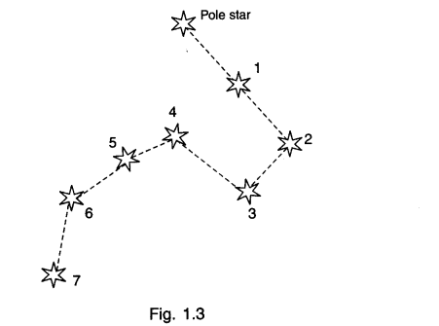
In the Fig. 1.3 shown here, 1 and 2 represent the “pointer stars”. The Pole Star and the pointer stars lie on the same line.
3. Write a short note on the two planets nearest to the sun.
Answer: Mercury- It is the nearest planet to the sun. It takes just about 88 earth days to revolve once around the sun. It is extremely hot since it is close to the sun. It is also the smallest planet.
Venus- It is the second closest planet to the sun. It is similar to earth in shape and size. It is called “Earth’s twin”.
4. How does earth support life? [V. Imp.]
Answer: The earth has conditions that support life. It is neither too hot nor too cold. It has both water and air, which are both indispensable for life. Presence of oxygen in the air in appropriate proportion supports life. These factors make earth a unique planet.
VII. Long Answer Type Questions
1. Write short notes on the following:
(a) The sun
(b) The moon
(c) Galaxy. [V. Imp.]
Answer:(a) The sun is considered the “head” of the solar system. It is a star, although it is smaller and less bright than most other stars. It is a huge celestial body made up of extremely hot gases. It provides heat and light for the whole of the solar system. Life on earth depends on many factors, and sunlight is one of them. The sun is about 150 million kilometres away from earth.
(b) The moon is the only natural satellite of our planet earth. Its diameter is just about a quarter of the earth’s diameter. It is comparatively closer (3,84,400 kilometres away) to earth than all other celestial bodies. It does not support life. It revolves around the earth and rotates about its own axis in about the same time, due to which only one side of the moon is visible to us.
(c) Galaxy is a term that refers to billions of stars, clouds of dust and gases, and other celestial bodies considered as a single unit. The only bigger unit is the universe, galaxies make up the universe. The galaxy we live in is called the Milky Way.
2. Draw a diagram showing the eight planets of the solar system in their orbits around the’ sun. Also prepare a table mentioning the length of their days and years.
Answer:
